
Department of Information and Communication Technology
Option of Information Technology
Module: Computational Methods
Module Code: GENCM801
Level 8 B-Tech

Practical Exam

Submitted By Group 8

Group Members: - NIYIGABA Claude 24RP14647
-BIBUKWISHAKA Jeremie 24RP14601

Question I

a) Describe the following methods for finding the local minimum and local maximum and identify the possible use cases for the methods
(i) The Equal interval search methods
Description:
The Equal Interval Search method is a simple optimization technique used to find the minimum or maximum of a unimodal function. It divides the search interval into equally spaced subintervals and evaluates the function at these points. Based on the function values, the interval containing the optimal solution is narrowed iteratively.
Use Cases:
Suitable for simple functions over a small interval where computational cost is not a concern. It is not efficient for high-accuracy requirements due to slow convergence.
- Simple optimization problems with a unimodal function.
- Situations where gradient-based methods cannot be applied due to non-differentiable functions.

(ii) the Golden section method
The Golden Section Search method is a more efficient technique for optimizing a unimodal function. It reduces the interval size using the golden ratio (≈ 0.618), minimizing the number of function evaluations compared to Equal Interval Search.
Use Cases:
Ideal for optimizing unimodal functions where a quick and efficient search is required. Common in engineering, economics, and physics.
- One-dimensional optimization problems, especially where function evaluations are expensive.
- Problems with continuous and unimodal functions.

b) provide the Golden search methods for finding the minimum
Algorithm:
- Define the interval [a,b][a,b] that contains the minimum.
- Calculate two interior points:

x₁ = $b-\frac{\left(b-a\right)}{ϕ}$ , x₂ = $a+\frac{\left(b-a\right)}{ϕ}$

- Evaluate f(x₁) and f(x₂):

If f(x₁) < f(x₂), the new interval is [a,x₂].

If f(x₁) > f(x₂), the new interval is [x_{1,b}].

- Repeat until the interval is sufficiently small.

The minimum is approximately at (𝑎+𝑏)/2(a+b)/2.

c) provide a block of the golden search method for finding the maximum ?

Algorithm:
- Define the interval [a,b][a,b] that contains the maximum.
- Calculate two interior points:

x₁ = $b-\frac{\left(b-a\right)}{ϕ}$ , x₂ = $a+\frac{\left(b-a\right)}{ϕ}$

- Evaluate f(x₁) and f(x₂):

If f(x₁) > f(x₂), the new interval is [a,x₂].

If f(x₁) < f(x₂), the new interval is [x_{1,b}].

- Repeat until convergence.
d) write a program (ii) in mathlab/python and submit the code chat help me by providing the clear an convincing answer to those question
Program
% A parabola with minimum at x = 2
f = @(x) (x - 2)^2 + 3;
% Define the interval
a = 0;
b = 9;

% Set tolerance
tol = 1e-9;

% Perform the Golden Section Search
[x_min, f_min] = golden_section_search(f, a, b, tol);

% Display the results
fprintf('The minimum x value is: %.9f\n', x_min);
fprintf('The minimum function value is: %.9f\n', f_min);

% Function definition at the end of the script
function [x_min, f_min] = golden_section_search(f, a, b, tol)

% Golden ratio
phi = (1 + sqrt(9)) / 2;
resphi = 2 - phi;

% Compute point c
c = a + resphi * (b - a);
% Compute point d
d = b - resphi * (b - a);
% Main loop for the search
while abs(b - a) > tol
if f(c) < f(d)
b = d; % Narrow interval to [a, d]
d = c; % Update d
c = a + resphi * (b - a); % Compute new c
else
% Narrow interval to [c, b]
a = c;
% Update c
c = d;
% Compute new d
d = b - resphi * (b - a);
end
end

% Midpoint of final interval
x_min = (a + b) / 2;
% Function value at x_min
f_min = f(x_min);
end

output
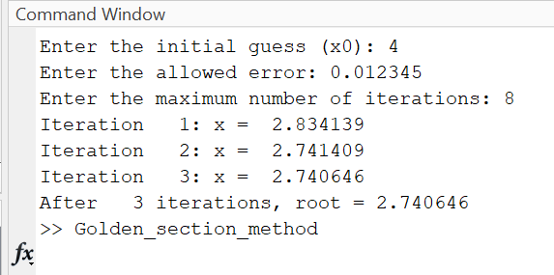
Question II
EXPERIMENT NO.- 1
Aim: Calculation of the value of unknown (y) corresponding to the given known (x) value using Newton Forward Formula of Interpolation.
Code
clc; % Clear the command window

% Input values
n = input('Enter the number of data points (n): ');

% Initialize arrays
x = zeros(n, 1);
y = zeros(n, 1);

disp('Enter the data points as [x, y]:');
for i = 1:n
data = input(sprintf('Point %d [x y]: ', i));
x(i) = data(1);
y(i) = data(2);
end

% Input the value of x for which y is to be interpolated
x_target = input('Enter the value of x for which y is wanted: ');

% Step size (h)
h = x(2) - x(1);

% Create the difference table
diff_table = zeros(n, n);
diff_table(:, 1) = y;

% Calculate forward differences
for j = 2:n
for i = 1:(n-j+1)
diff_table(i, j) = diff_table(i+1, j-1) - diff_table(i, j-1);
end
end

% Display the difference table
disp('Difference Table:');
disp(diff_table);

% Find the interval containing x_target
i = 1;
while i <= n && x(i) <= x_target
i = i + 1;
end
i = i - 1;

% Calculate p
p = (x_target - x(i)) / h;
%adsfghj
% Interpolation using Newton's forward formula
y_target = y(i);
nr = 1;
dr = 1;
for k = 1:n-1
nr = nr * (p - (k-1));
dr = dr * k;
y_target = y_target + (nr / dr) * diff_table(i, k+1);
end

% Display the result
fprintf('When x = %.2f, y = %.4f\n', x_target, y_target);

Results
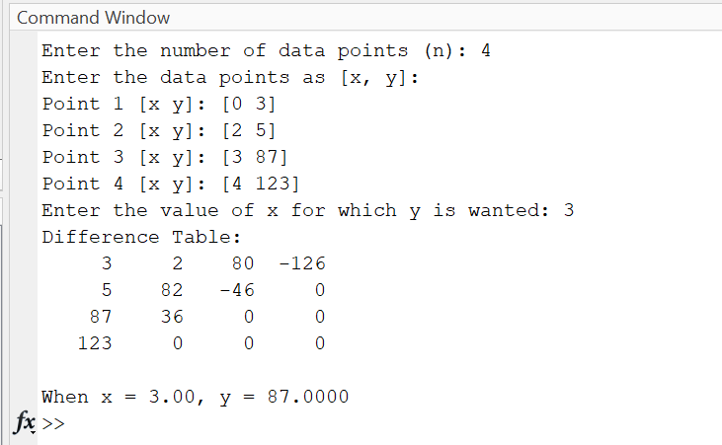
EXPERIMENT No. 2
AIM: Solution of Non- Linear Equation in single variable using the method of successive bisection.
Code
clc; % Clear the command window

% Define the function
f = @(x) x^3 - 4*x - 9;

% Input the interval, error tolerance, and max iterations
a = input('Enter the lower bound (a): ');
b = input('Enter the upper bound (b): ');
allowed_error = input('Enter the allowed error: ');
max_iterations = input('Enter the maximum number of iterations: ');

% Check if root lies within the interval
if f(a) * f(b) > 0
disp('The function has the same sign at a and b. Root may not exist in this interval.');
return;
end

% Initialize variables
itr = 0;
x = (a + b) / 2; % Initial midpoint
fprintf('Iteration %3d: x = %7.5f\n', itr, x);

% Start the Bisection Method
while itr < max_iterations
itr = itr + 1;
x_old = x;
% Check which subinterval contains the root
if f(a) * f(x) < 0
b = x;
else
a = x;
end

% Calculate new midpoint
x = (a + b) / 2;
fprintf('Iteration %3d: x = %7.5f\n', itr, x);

% Check for convergence
if abs(x - x_old) < allowed_error
fprintf('Root found after %d iterations: x = %7.5f\n', itr, x);
return;
end
end

% If the method does not converge
disp('Solution did not converge within the maximum number of iterations.');

Result
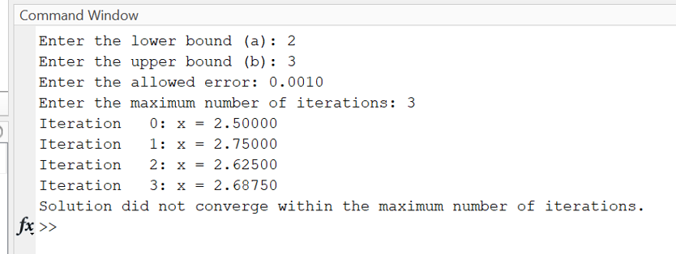
EXPERIMENT NO: 3
Aim: - Solution of Non – linear equation in single variable using the Regula – Falsi, Newton – Raphson method.
Code: clc; % Clear the command window
clear; % Clear variables
close all; % Close any open figures

% Define the function
f = @(x) cos(x) - x * exp(x);

% Input the initial guesses, allowed error, and max iterations
x0 = input('Enter the first guess (x0): ');
x1 = input('Enter the second guess (x1): ');
allowed_error = input('Enter the allowed error: ');
max_iterations = input('Enter the maximum number of iterations: ');

% Check if the root lies in the interval
if f(x0) * f(x1) > 0
disp('The function has the same sign at x0 and x1. Root may not exist in this interval.');
return;
end

% Initialize variables
itr = 0;
x2 = x0; % Start with x0 as the initial value
fprintf('Iteration %3d: x = %7.5f\n', itr, x2);

% Start the Regula Falsi Method
while itr < max_iterations
itr = itr + 1; % Increment the iteration counter

% Calculate the new approximation using Regula Falsi formula
x2 = x0 - (f(x0) * (x1 - x0)) / (f(x1) - f(x0));
fprintf('Iteration %3d: x = %7.5f\n', itr, x2);

% Check if the root lies in the left or right interval
if f(x0) * f(x2) < 0
x1 = x2;
else
x0 = x2;
end

% Check for convergence
if abs(f(x2)) < allowed_error
fprintf('Root found after %d iterations: x = %7.5f\n', itr, x2);
return;
end
end

% If the method does not converge
disp('Solution did not converge within the maximum number of iterations.');
RESULTS:
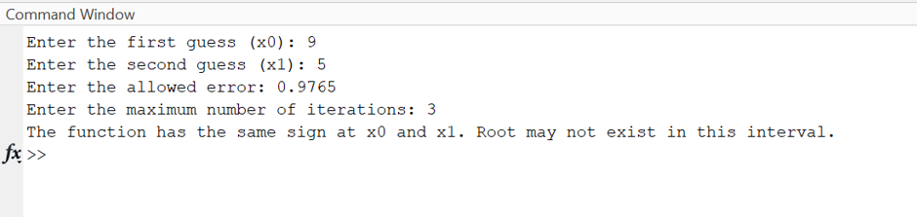

EXPERIMENT NO: 4
clc; % Clear the command window

% Define the function and its derivative
f = @(x) x * log10(x) - 1.2; % Function
df = @(x) log10(x) + 0.43429; % Derivative of the function

% Input initial guess, allowed error, and maximum iterations
x0 = input('Enter the initial guess (x0): ');
allowed_error = input('Enter the allowed error: ');
max_iterations = input('Enter the maximum number of iterations: ');

% Start the Newton-Raphson Method
for itr = 1:max_iterations
h = f(x0) / df(x0); % Calculate the step
x1 = x0 - h; % Update the root approximation
fprintf('Iteration %3d: x = %9.6f\n', itr, x1);

% Check for convergence
if abs(h) < allowed_error
fprintf('After %3d iterations, root = %8.6f\n', itr, x1);
return;
end

x0 = x1; % Update x0 for the next iteration
end

% If the method does not converge
disp('Solution did not converge: maximum iterations reached.');

Result
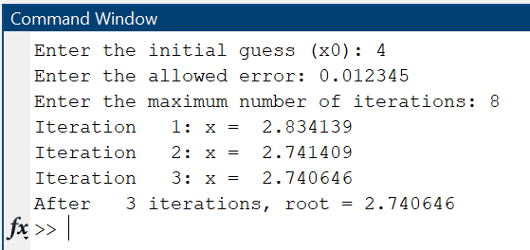
EXPERIMENT NO: 5

Aim: Solution of a system of simultaneous algebraic equation using Gaussian elimination
procedure.

clc; % Clear command window
clear; % Clear variables
close all; % Close all figures

% Input size of the system
N = input('Enter the number of variables: ');

% Input augmented matrix
disp('Enter the elements of the augmented matrix row-wise:');
A = zeros(N, N+1); % Augmented matrix
for i = 1:N
for j = 1:N+1
A(i, j) = input(sprintf('A(%d,%d): ', i, j));
end
end

% Forward elimination (Upper triangular matrix)
for j = 1:N-1
for i = j+1:N
factor = A(i, j) / A(j, j);
for k = 1:N+1
A(i, k) = A(i, k) - factor * A(j, k);
end
end
end

% Display the upper triangular matrix
disp('The upper triangular matrix is:');
disp(A);

% Back substitution to find solution
x = zeros(N, 1); % Solution vector
for i = N:-1:1
sum = 0;
for j = i+1:N
sum = sum + A(i, j) * x(j);
end
x(i) = (A(i, N+1) - sum) / A(i, i);
end

% Display the solution
disp('The solution is:');
for i = 1:N
fprintf('x(%d) = %.4f\n', i, x(i));
end

Result:
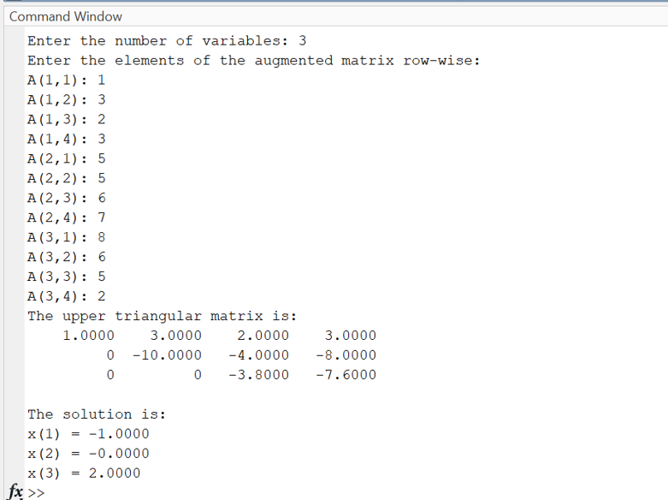

EXPERIMENT NO: 6
AIM: - Calculation of integral value of a given function using Trapezoidal Rule of Numerical Integration

Code
clc; % Clear command window
% Define the function to integrate
y = @(x) 1./(1 + x.^2);

% Input the limits and number of subintervals
x0 = input('Enter the lower limit (x0): ');
xn = input('Enter the upper limit (xn): ');
n = input('Enter the number of subintervals (n): ');

% Calculate step size
h = (xn - x0) / n;

% Apply the Trapezoidal Rule
s = y(x0) + y(xn);
for i = 1:n-1
xi = x0 + i * h; % Calculate intermediate points
s = s + 2 * y(xi); % Add twice the intermediate terms
end

% Compute the integral
integral = (h / 2) * s;

% Display the result
fprintf('The value of the integral is: %.4f\n', integral);

OUTPUT RESULT
